GISNE GARNIA 2019804358 Senin, 14 Des 2020
UAS Prak.Algoritma dan pempgraman 2
Dosen Adi Irwanto, M.kom

Jawaban
#include<iostream>
using namespace std;
void bubbleSort(int data[], int n){
int temp;
for (int i = 0; i < n-1; i++)
{
for (int j = i+1; j < n; j++)
{
if (data[i]>data[j])
{
temp = data[i];
data[i]=data[j];
data[j]=temp;
}
}
}
}
int main(){
int length;
cout<<" Nama : GISNE GARNIA "<<endl;
cout<<" Kelas : SISTEM INFORMASI"<<endl;
cout<<" Mata Kuliah : Algoritma & Pemoggraamaan 2 "<<endl<<endl;
cout<<"ALGORITMA PENGURUTAN BUBLE SORT"<<endl;
cout<<"Masukkan banyak elemen : ";
cin>>length;
cout<<"Masukan Nilai"<<endl;
int data[length];
for (int i = 0; i < length; i++)
{
cout<<"Nilai :"<<" = ";
cin>>data[i];
}cout<<endl;

cout<<"Data belum terurut : "<<endl;
for (int i = 0; i < length; i++)
{
cout<<data[i]<<" ";
}cout<<endl;

bubbleSort(data,length);
cout<<"Data sudah terurut : "<<endl;
for (int i = 0; i < length; i++)
{
cout<<data[i]<<" ";
}cout<<endl;

}

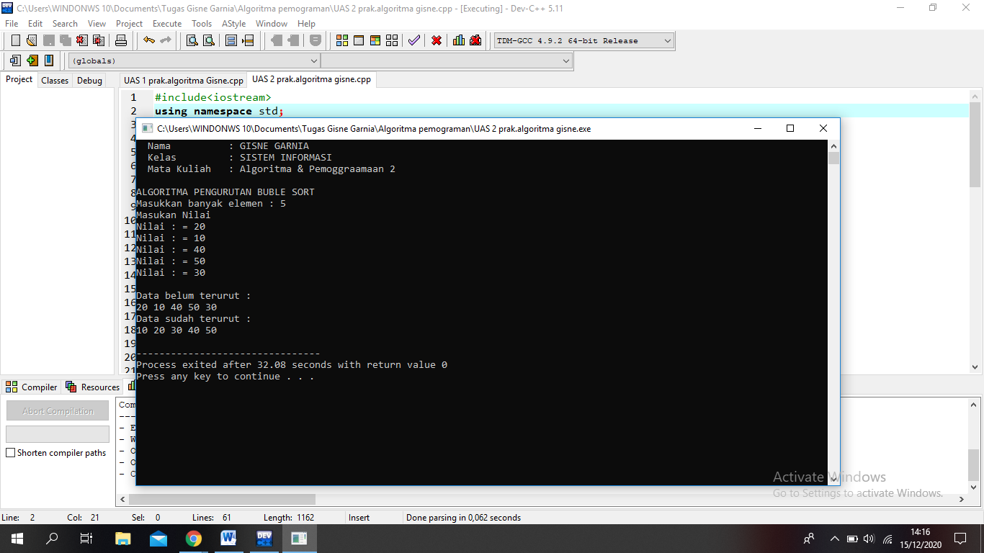

#include<iostream>
#include<conio.h>
#include<iomanip>
using namespace std;
main()
{
cout<<endl;
cout<<" Nama : GISNE GARNIA "<<endl;
cout<<" Kelas : SISTEM INFORMASI"<<endl;
cout<<" Mata Kuliah : Algoritma & Pemoggraamaan 2 "<<endl<<endl;

int a[3][3],b[3][3],c[3][3],i,j,k;

cout<<" Matriks 3 x 3 :";
cout<<endl;;
for(i=0;i<3;i++){
for(j=0;j<3;j++){

cout<<" Input Baris "<<(i+1)<<" , Kolom "<<(j+1)<<" = ";

cin>>a[i][j];}
cout<<endl;}

cout<<" Matriks 3 x 3 = "<<endl<<endl;

for(i=0;i<3;i++){
for(j=0;j<3;j++){
cout<<setw(4)<<a[i][j];}
cout<<endl<<endl;}
getch ();
}

